Bryan Diaz

Ana Aleksandric

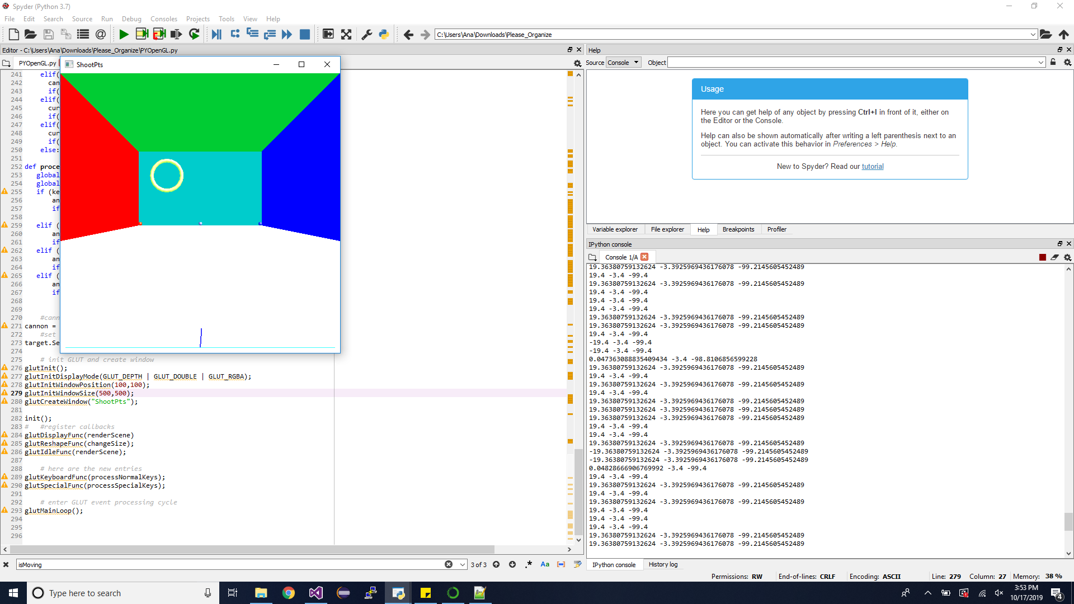

For this project we chose Python. At the very beginning, Bryan did the biggest part of the code. However, he was not able to run it or test it, since he had Anaconda (Spyder) problem. So, the code ended up with me. I had troubles with OpenGL window popping up in general I found some simple OpenGl code and tried to run it, but did not work. That was the biggest issue we had about this programming assignment. I had to download and install unofficial packages from this website: <https://www.lfd.uci.edu/~gohlke/pythonlibs/> , we installed them using pip install, and then anaconda was able to recognize OpenGL function in the code. For some reason this did not work on Bryan’s PC. Then we had to fix parts of the code that did not work. The main difference in our code than in c++ code is that c++ code uses linked list to store the balls, while we used a regular list in python. It was much simpler to do it this way.

In my opinion, I like c++ more than Python, mainly because readability and writability. While I was coding, almost every time I added a new line of code, I would get an error that there is a spacing problem. I am not sure if compiler can somehow fix this automatically, but we were doing it manually and it was taking a lot of time. Also, missing of {} makes code less readable (at least to me). I liked this assignment, since I got a general idea about Python and I had Bryan to help me understand better certain concepts.

While we were working on this project, we received some help from Tom as well, who was trying to help us fix some issues.

Bryan: Hey Dr. Rodriguez can we have a test next Friday. Ana really need it.